Assignment 7-Provide User Feedback

# Task 1 - Please Wait, Reticulating Splines

The mobile device has some limited environments compare the desktop and laptop device. It has limited CPU, memory, disk (persistent storage), Small Screen without pointer and battery can used out. Application need provides visual feedback to user that the system is still working.

1. Slowly networking

The slowly 3G networking may need long period time to download or upload file. The application should run in multiple threads to keep application still alive. Usually, UIProgressView and UIActivityIndicatorView is used to tell user current progress. If the Internet operation lasts a few seconds, a UIActivityIndicatorView is fair enough to provide feedback. If the internet operation takes 10 seconds or more, the UIProgressView is a better choices.

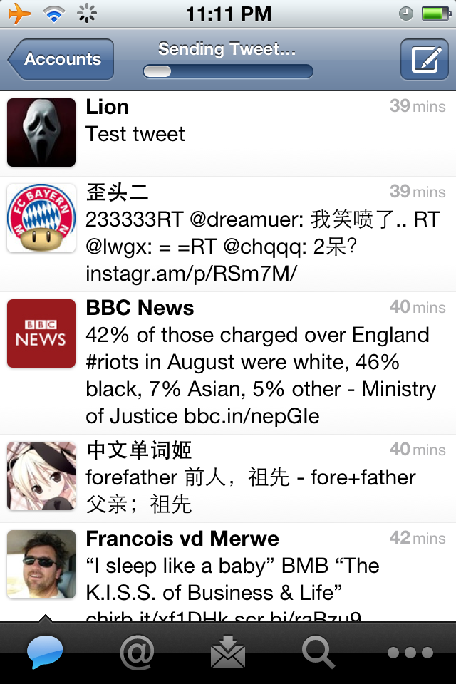

Figure 1: update tweet with customer UIProgressView (source: from Twitter)

1. GPS

Some LBS (Location Base Service) app need use GPS to get use’s location. If user disables GPS by airplane model or user is in the underground, they are not able to locating on the Google maps. A UIAlertView should be used to tell user the device’s GPS is disabled and bring user to settings to enable GPS. A UIActivityIndicatorView is still useful, when GPS try to locate user in the maps.

1. Large application loading to memory

The iOS operation system supports OpenGL ES. It can provide awesome graphic 3D gaming to users. If application has started, it need load lots of resource into memory, like video, image and audio. A splash image should display when loading resource to memory. When it is loading, application should display a UIProgressView to indicate user when will finish loading.



Figure 2: Loading game with UILabel and UIActivityIndicatorView

(source: screen shots from MetalStorm App)

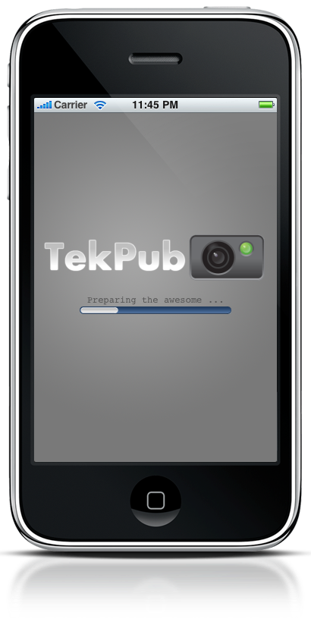

Figure 3: Splash Screen with UIProgressView

(source: <http://benscheirman.com/2010/06/building-an-iphone-app-for-tekpub-splash-screen>)

1. Airplane Mode

GPS is the most power-consuming component in mobile device. When GPS is turned on, it need always search satellite to update user’s location on the map. However other sensors only work when user needs it. Also GPS is allowed worked on background. User may turn on airplane mode to save power. If user perform a networking operation or use GPS function, a UIAlertView should popup, then ask user turns off airplane mode.

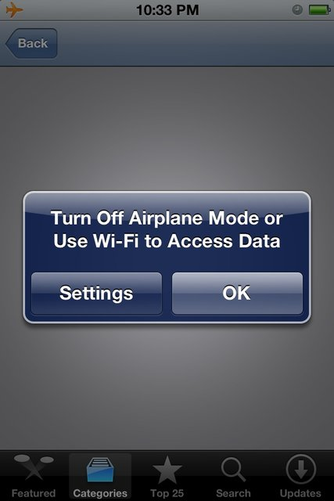

Figure 4: Screen shots from my iPod Touch

1. UILabel for all long time operations

The UILabel can display text information to users. When a application process a long time operation, UIlabel can display “Still Working ……” or “Loading” to indicate user progress. When application finished operation, UILabel should disappear.

# Task 2 – Spin Cycle

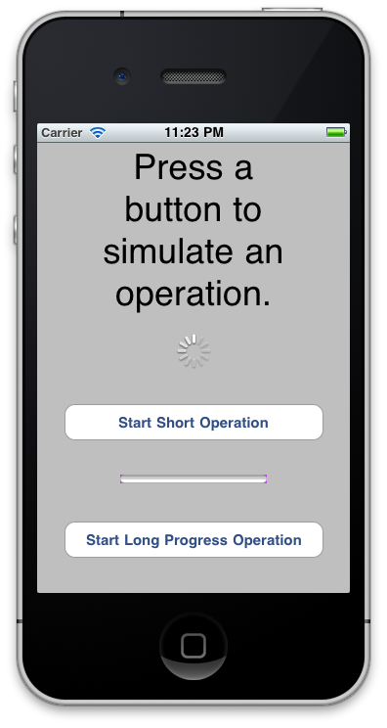

Figure 5: Screen shots from “Spin Cycle” project

See code on appendix